Data Report

# Deliverable 3.3.2 – January 9, 2017

### State Participation in 2016 State Reports

Since 2001, the 50 states, the District of Columbia, Guam, and the Commonwealth of Puerto Rico (Puerto Rico) have participated in Title II reporting. The United States Virgin Islands (Virgin Islands) began reporting in 2002. American Samoa, the Federated States of Micronesia (Micronesia), the Republic of the Marshall Islands (Marshall Islands), the Commonwealth of the Northern Mariana Islands (Northern Mariana Islands), and the Republic of Palau (Palau) began reporting in 2006. The *Higher Education Act* (*HEA)* defines all of these jurisdictions as *states*, and for the purposes of this report, the term *state* refers to all of these jurisdictions. Of the 59 states required to report, all 59 complied with the reporting requirements by submitting State Report Cards in 2016.

### Selected Findings from 2016 State Reports

#### Teacher Preparation Providers and Programs

* In 2016, states reported data on 2,139 teacher preparation providers.
* States reported three types of teacher preparation providers: 1,480 (69 percent) traditional teacher preparation providers, 455 (21 percent) alternative teacher preparation providers based at institutions of higher education (IHEs), and 204 (10 percent) alternative teacher preparation providers not based at IHEs.
* States also reported the number of individual programs within each teacher preparation provider. Individual programs prepare prospective teachers for the specific level or content area in which they plan to teach, such as elementary education, special education, mathematics, English, or science. States reported 27,568 teacher preparation programs in 2016.
* Of the 27,568 teacher preparation programs reported in 2016, 19,260 (70 percent) are based in traditional teacher preparation providers, 5,158 (19 percent) are based in alternative teacher preparation providers based at IHEs, and 3,150 (11 percent) are based in alternative teacher preparation providers not based at IHEs.

***Teacher Preparation Program Enrollment***

* For Title II reporting purposes, an *enrolled student* is an individual admitted into a teacher preparation program who has not yet completed the program. In applying this definition, individuals who completed the program within the academic year being reported are counted as program completers, and are not included in the enrollment count.
* During academic year (AY) 2014–15, teacher preparation programs enrolled 436,160 individuals, a 6 percent decrease from 465,189 individuals enrolled in AY 2013–14.
  + Traditional teacher preparation programs enrolled 357,449 individuals (82 percent) in AY 2014–15, a 10 percent decrease from 397,386 individuals enrolled in traditional programs in AY 2013–14.
  + Alternative-route teacher preparation programs based at IHEs enrolled 25,941 individuals (6 percent) in AY 2014–15, a 2 percent decrease from 26,362 individuals enrolled in AY 2013–14.
  + Alternative-route teacher preparation programs not based at IHEs enrolled 52,770 individuals (12 percent) in AY 2014–15, a 27 percent increase from 41,441 individuals enrolled in AY 2013–14.
* Overall, teacher preparation program enrollment has been decreasing since AY 2009–10, with the most substantial decrease between AY 2011–12 and AY 2012–13. Appendix A discusses the trend of decreasing enrollment.

***Teacher Preparation Program Completers***

* Teacher preparation programs prepared a total of 172,150 completers in AY 2014–15. This completion rate represented a decrease of 5 percent from the previous academic year (180,481 in AY 2013–14).
  + Traditional teacher preparation programs prepared 139,443 completers in AY 2014–15, representing a 7 percent decrease from the previous academic year (149,331 in AY 2013–14).
  + Alternative-route teacher preparation programs based at IHEs prepared 12,689 completers in AY 2014–15, representing a 2 percent decrease from the previous academic year (12,927 in AY 2013–14).
  + Alternative-route teacher preparation programs not based at IHEs prepared 20,018 completers in AY 2014–15, representing a 10 percent increase from the previous academic year (18,223 in AY 2013–14).

#### Individuals Earning an Initial Teaching Credential

* States reported the total number of individuals receiving an initial teaching credential in the state and the subset of those individuals who completed their teacher preparation in another state.
* In AY 2014–15, states reported a total of 248,499 individuals receiving initial teaching credentials, which represented a 3 percent decrease from the previous academic year (254,963 in AY 2013–14).
  + In AY 2014–15, 79 percent (196,330) of individuals receiving an initial credential completed their teacher preparation in the same state in which they earned their credential; 21 percent (52,169) completed their teacher preparation in another state. This distribution was similar to AY 2013–14, when 78 percent (198,482) of individuals receiving an initial teaching credential completed their teacher preparation in the same state in which they earned their credential, and 22 percent (56,481) completed their teacher preparation in another state.

#### Demographics of Individuals Enrolled in Teacher Preparation Programs

* In AY 2014–15, 76 percent of individuals enrolled in teacher preparation programs who reported their gender[1] were female (325,242) and 24 percent were male (105,444). This distribution was similar to AY 2013–14, when 76 percent of individuals enrolled in teacher preparation programs who reported their gender[2] were female (347,210) and 24 percent were male (109,622).

Note: This figure presents data on the 430,686 individuals who were enrolled in teacher preparation programs and who reported their gender in AY 2014 – 15. The 1 percent of individuals enrolled in teacher preparation programs who did not report their gender were excluded from the calculations.

* There has been little change in the gender distribution of individuals enrolled in teacher preparation programs during the last 5 years. The enrollment of females and males has remained relatively constant since AY 2011–12 at 76 percent and 24 percent, respectively.

Note: This figure presents data on the individuals who were enrolled in teacher preparation programs and who reported their gender. Individuals enrolled in teacher preparation programs who did not report their gender were excluded from the calculations. In AY 2014 – 15, states did not report gender data for 5,474 individuals, or 1 percent of all individuals enrolled in teacher preparation programs. In AY 2013 – 14, states did not report gender data for 8,357 individuals, or 2 percent of all individuals enrolled in teacher preparation programs. In AY 2012 – 13, states did not report gender data for 5,847 individuals, or 1 percent of all individuals enrolled in teacher preparation programs. In AY 2011 – 12, states did not report gender data for 4,719 individuals, or 1 percent of all individuals enrolled in teacher preparation programs. In AY 2010 – 11, states did not report gender data for 4,385 individuals, or 1 percent of all individuals enrolled in teacher preparation programs.

* Although enrollees in teacher preparation programs are overwhelmingly female, alternative teacher preparation programs tend to attract a higher proportion of males than do traditional programs. The percentage of males enrolled in alternative teacher preparation programs is 9 percent points greater than those enrolled in traditional programs.

Note: This figure presents data on the 430,686 individuals who were enrolled in teacher preparation programs and who reported their gender. The 1 percent of individuals enrolled in teacher preparation programs who did not report their gender were excluded from the calculations.

* In AY 2014–15, among individuals enrolled in teacher preparation programs who reported their race/ethnicity[3], 70 percent (277,156) identified as White, 13 percent (53,292) identified as Hispanic, and 9 percent (36,589) identified as Black. In AY 2013–14, 71 percent (307,067) of individuals enrolled in teacher preparation programs who reported their race/ethnicity[4] identified as White, 12 percent (51,536) identified as Hispanic, and 10 percent (44,632) identified as Black.

Note: This figure presents data on the 394,842 individuals who were enrolled in teacher preparation programs and who reported their race/ethnicity. The 9 percent of individuals enrolled in teacher preparation programs who did not report their race/ethnicity were excluded from the calculations.

* Based on the individuals enrolled in teacher preparation programs who reported their race/ethnicity,[5] it appears the field of prospective teachers has become increasingly more diverse in the past 5 years. The percentage of minority enrollment in teacher preparation programs has increased every year since AY 2010–11. The highest percentage of minority enrollment in teacher preparation programs occurred in AY 2014–15 at 30 percent.

Note: This figure presents data on the individuals who were enrolled in teacher preparation programs and who reported their race/ethnicity. Individuals enrolled in teacher preparation programs who did not report their race/ethnicity were excluded from the calculations. In AY 2014 – 15, states did not report race/ethnicity data for 41,318 individuals, or 9 percent of all individuals enrolled in teacher preparation programs. In AY 2013 – 14, states did not report race/ethnicity data for 34,867 individuals, or 7 percent of all individuals enrolled in teacher preparation programs. In AY 2012 – 13, states did not report race/ethnicity data for 28,259 individuals, or 6 percent of all individuals enrolled in teacher preparation programs. In AY 2011 – 12, states did not report race/ethnicity data for 25,950 individuals, or 4 percent of all individuals enrolled in teacher preparation programs. In AY 2010 – 11, states did not report race/ethnicity data for 28,502 individuals, or 4 percent of all individuals enrolled in teacher preparation programs.

#### Evaluation of Teacher Preparation Programs

* Fourteen states and Puerto Rico reported teacher preparation programs that were low performing or at risk of low performance (at risk) in AY 2014–15.
* Nineteen teacher preparation providers in six states (California, Connecticut, Maryland, Michigan, New York, and Ohio) and Puerto Rico reported low-performing teacher preparation programs in AY 2014–15.
* Thirty-three teacher preparation providers in 10 states (California, Idaho, Iowa, Kansas, Kentucky, Michigan, Oklahoma, South Carolina, Texas, and Virginia) and Puerto Rico reported at-risk teacher preparation programs in AY 2014–15.
* Of the 19 teacher preparation providers with programs designated as low performing in AY 2014–15, 16 were traditional teacher preparation providers and three were alternative teacher preparation providers based at IHEs.
* Of the 33 teacher preparation providers with programs designated as at-risk in AY 2014–15, 31 were traditional teacher preparation providers, one was an alternative teacher preparation provider based at an IHE, and one was an alternative teacher preparation provider not based at an IHE.
* Of the states and jurisdictions that did not identify any programs as low performing or at risk in AY 2014–15, 29 have never identified any programs as being low performing or at risk: Alaska, Arizona, Arkansas, Colorado, Delaware, Hawaii, Massachusetts, Minnesota, Montana, Nebraska, Nevada, New Hampshire, New Jersey, New Mexico, North Dakota, Pennsylvania, South Dakota, Utah, Vermont, West Virginia, Wisconsin, the District of Columbia, American Samoa, Guam, Marshall Islands, Micronesia, Northern Mariana Islands, Palau, and Virgin Islands.

## Twenty-nine states have never identified at-risk or low-performing programs.

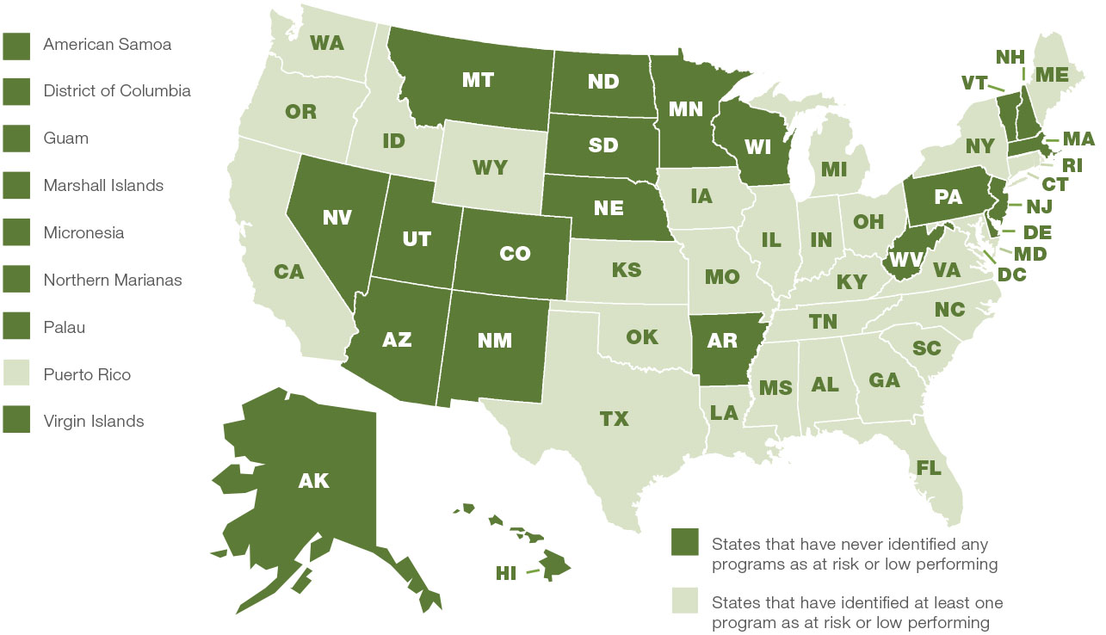

## Appendix A:

## A Discussion on the Decreasing Enrollment in Teacher Preparation Programs

The decrease in teacher preparation program enrollment follows a larger trend of declining enrollment in postsecondary education between AY 2010 – 11 and AY 2013 – 14. However, teacher preparation program enrollment declined at a faster rate than overall postsecondary education enrollment. The disparity between the rate of decline in overall postsecondary education enrollment and teacher preparation program enrollment suggests that, proportionate to the overall college-going population, fewer individuals are choosing to pursue a career in teaching. According to an American College Testing (ACT) report, 16 percent fewer high school students during the past 4 years say they are pursuing a career in teaching (Higgins, 2015).

Research suggests that declining morale and job satisfaction among current teachers may contribute to the decrease in individuals pursuing teaching as a career. The MetLife Survey of the American Teacher reported that teacher job satisfaction had declined to its lowest point in 25 years, after having dropped from 62 percent in 2008 to only 39 percent in 2012. The report also described that more than half of all teachers report feeling a great amount of stress and that budget decreases have led to lower morale for teachers (MetLife, Inc., 2013). In a 2015 interview with National Public Radio, Bill McDiarmid, the dean of the University of North Carolina School of Education, pointed to a growing sense that “teachers simply have less control over their professional lives in an increasingly bitter, politicized environment” (Westervelt, 2015).

Some also point to the economy as a factor for the decline in teacher preparation program enrollment, which began to drop following the 2008 recession. A 2015 study shows that when there is a recession in the economy, both men and women are less likely to pursue teaching, instead turning to fields like accounting and engineering (Blom, Cadena, & Keys, 2015). According to a report from the Center for American Progress (CAP), fewer people enroll in teacher preparation programs in states that have lower teacher salaries and have more layoffs (Partelow and Baumgardner, 2016). The “last-hired, first-fired” practice that many districts follow for staff reductions due to budget cuts may also dissuade young students from becoming teachers (Gordon, 2011).

The downward trend in teacher preparation program enrollment was present across all three teacher preparation program types since AY 2009 – 10 through AY 2012 – 13. Although enrollment in traditional teacher preparation programs has continued to decline through AY 2014 – 15, enrollment in alternative, IHE-based programs and in alternative, not IHE-based programs both reversed their downward trend, with both alternative program types seeing an increase in AY 2013 – 14. In AY 2014 – 15, enrollment in alternative, not IHE-based programs continued to increase, while enrollment in alternative, not IHE-based programs decreased. Alternative programs tend to attract individuals that are switching careers or other types of non-traditional students.

Research is thin on reasons for the differing trends in enrollment for traditional versus alternative teacher preparation programs. The economy may play a factor in the types of prospective teachers drawn to teaching during a recession. Although college students are less likely to pursue teaching during an economic recession, it is possible that the same economic factors that deter young college students from selecting education as a career path (and thus enrolling in a traditional teacher preparation program) could lead non-traditional students/career-changers to enroll in an alternative teacher preparation program (for example, a former journalist for a print newspaper that has shut its doors).

## Appendix B:

## Works Cited

Blom, E., Cadena, B., & Keys, B. (2015). *Investment over the Business Cycle: Insights from College Major Choice*. IZA Discussion Paper No. 9167. Germany: Institute for the Study of Labor (IZA). Retrieved from <http://ftp.iza.org/dp9167.pdf>.

Gordon, L. (2011, April 3). Today’s teacher layoffs threaten tomorrow’s college classrooms. *Los Angeles Times*.

Higgins, L. (2015, April 25). Who wants to teach? Prep program numbers declining. *Detroit Free Press.*

MetLife, Inc. (2013). *The MetLife Survey of the American Teacher: Challenges for School Leadership*. Retrieved from <https://www.metlife.com/assets/cao/foundation/MetLife-Teacher-Survey-2012.pdf>.

Partelow, L. and Baumgardner, C. (2016). *Educator Pipeline at Risk: Teacher Labor Markets After the Great Recession*. Center for American Progress. Retrieved from: <https://cdn.americanprogress.org/wp-content/uploads/2016/09/14084443/TeacherPrep-report.pdf>.

Westervelt, E. (2015, March 3). Where Have All The Teachers Gone? *National Public Radio.* Retrieved from: <http://www.npr.org/sections/ed/2015/03/03/389282733/where-have-all-the-teachers-gone>

1. In AY 2014 – 15, states did not report gender data for 5,474 individuals, or 1 percent of all individuals enrolled in teacher preparation programs.
2. In AY 2013 – 14, states did not report gender data for 8,357 individuals, or 2 percent of all individuals enrolled in teacher preparation programs.
3. In AY 2014 – 15, states did not report race/ethnicity data for 41,318 individuals, or 9 percent of all individuals enrolled in teacher preparation programs.
4. In AY 2013 – 14, states did not report race/ethnicity data for 34,867 individuals, or 7 percent of all individuals enrolled in teacher preparation programs.
5. In AY 2014 – 15, states did not report race/ethnicity data for 41,318 individuals, or 9 percent of all individuals enrolled in teacher preparation programs. In AY 2013 – 14, states did not report race/ethnicity data for 34,867 individuals, or 7 percent of all individuals enrolled in teacher preparation programs. In AY 2012 – 13, states did not report race/ethnicity data for 28,259 individuals, or 6 percent of all individuals enrolled in teacher preparation programs. In AY 2011 – 12, states did not report race/ethnicity data for 25,950 individuals, or 4 percent of all individuals enrolled in teacher preparation programs. In AY 2010 – 11, states did not report race/ethnicity data for 28,502 individuals, or 4 percent of all individuals enrolled in teacher preparation programs.